|  |
| --- |
|  |
| SOVY |
| Digital Calculator PO1_DGC_HSI |

# Table of Contents

1. Document Status ……………………………………………………………………...2
2. Document History ……………………………………………………………………...2
3. Reference Documents ……………………………………………………………….....2
4. Project Description ……………………………………………………………………..3
5. System Context Diagram ……………………………………………….…………….....3
6. System Requirements …………………………………………………………………....4
7. LCD Features …………...…………………………………………………………...…...5
8. Hardware Features………………………………………………………………………..6

# Document Status

|  |  |
| --- | --- |
| Name | SOVY |
| Version | 1.2 |
| Status | Proposed |
| Author | HM |
| Date | 13/2/2021 |

# Document History

|  |  |  |  |
| --- | --- | --- | --- |
| Version | Author | Date | Change |
| 1.0 | NK, NM | 13/2/2021 | Initial Creation |
| 1.1 | NK, NM | 14/2/2021 | Updating the system context diagram |
| 1.2 | HM | 19/2/2021 | Updating the requirements ID’s and making them atomic.  Added: -  -  Edited :  -  - |

# Reference Documents

|  |  |  |  |
| --- | --- | --- | --- |
| Ref. No. | Doc. Name | Version | Status |
| 1 | PO1_DGC_CR_DigitalCalculator | 1.0 | Released |

# Project Description

“Sovy” is a simple digital calculator which consists of a keypad which contains all the buttons required to perform any basic mathematical operations and a LCd-screen to displays the operation. A tune is generated from a buzzer every time the user presses a key.

# System Context Diagram

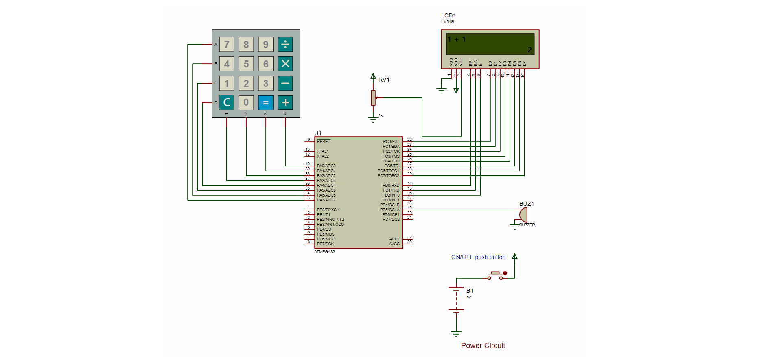

# System Requirements

|  |  |  |  |
| --- | --- | --- | --- |
| Req_ID | Req_1ST123_HSI_overall_001-V1.0 | Covers | Covers_1ST123_CR _01-V1.0 |
| Description: | The Keypad(4x4) in total contains 16 keys, each of one is used to send a particular input to the microcontroller as required by the user. 10 keys are used for numbers from 0 to 9. 4 keys are used for addition, subtraction, multiplication, division. Each row and column in the keypad has a separate pin which is connected to separate pin on the Atmega32 microcontroller. There is also a (C) switch that is responsible for switching the system on/off (Lcd & Keypad). | | |

|  |  |  |  |
| --- | --- | --- | --- |
| Req_ID | Req_1ST123_HSI_overall_002-V1.0 | Covers | Covers_1ST123_CR _02-V1.0 |
| Description: | Describes the connections of the keypad with the microcontroller. Initially, all the rows and columns are logic high. Each row is made logic low one by one. And the corresponding column which is made logic low, by a key press, is detected. The detected row and column numbers are scanned in the array (software) which return the corresponding number entered assigned to the pressed key. | | |

|  |  |  |  |
| --- | --- | --- | --- |
| Req_ID | Req_1ST123_HSI_overall_003-V1.0 | Covers | Covers_1ST123_CR _03-V1.0 |
| Description: | An LCD Display of 16x2 characters is used to display the output of this project. The LCD Display was directly interfaced to the microcontroller. It will output any data fed to it on its data lines. | | |

|  |  |  |  |
| --- | --- | --- | --- |
| Req_ID | Req_1ST123_HSI_overall_004-V1.0 | Covers | Covers_1ST123_CR _03-V1.0 |
| Description: | When a particular row is set low, and happens that the 1st operand of the operation to be in this row and is pressed, the corresponding column is set low and a key press, is detected. By that time, the LCD will be initialized and ready for receiving data. Then, it will be displayed on the LCD. Similarly, the operator and the 2nd operand will also be displayed. And by pressing the equal key, the result will be displayed. | | |

|  |  |  |  |
| --- | --- | --- | --- |
| Req_ID | Req_1ST123_HSI_overall_005-V1.0 | Covers | Covers_1ST123_CR _04-V1.0 |
| Description: | When any key in the keypad is pressed, it will generate a high pulse when it is released, which will turn the buzzer on. | | |

# LCD Features

|  |  |
| --- | --- |
| 1.Vdd | The supply voltage of the LCD. 5V DC is supplied from the Microcontroller to this pin to turn on the LCD. |
| 2. Vss | The Ground Connection of the LCD. It is connected to the ground. |
| 3. Vo | The Contrast Control Pin. It is connected to a potentiometer in order to control the contrast for the display. |
| 4. R/W pin | This pin is used to select between the Read and Write Option of the LCD. When this pin is made logic low, a write operation is performed and data is sent from the microcontroller to the LCD using the D0-D7 pins. When this pin is set high, a read operation is performed and data is sent from the LCD to the microcontroller using the D0-D7 pins on the LCD. |
| 5. Register Select pin | This pin is used to select whether to send data to display or perform some command on the LCD. When this pin is set high, a write operation will send data onto the data register for displaying on the LCD. When this pin is set low, a write operation will send some LCD specific command to be performed on the LCD. |
| 6. Enable Pin | This pin is used to enable the LCD. It is operated on the rising edge of a pulse. When data is fed onto the data lines and the R/W pin set, application of a short pulse will result in data being sent to the LCD. |
| 7. Data pins | These 8 pins are used as a bus to send or receive data between the microcontroller and the LCD. |
| 8. A(Led positive) pin | Connected to 5v. |
| 9.K(Led negative) pin | Connected to ground. |

# Hardware Features

|  |  |
| --- | --- |
| Hardware Component | Features |
| 1. LCD | This 16x2 LCD display has the outline size of 80.0 x 36.0 mm and VA size of 66.0 x 16.0 mm and the maximum thickness is 13.2 mm. WH1602W 16x2 LCD Displays are built-in controller ST7066 or equivalent. It is optional for + 5.0 V or + 3.0 V power supply. The LEDs can be driven by pin 1, pin 2, or pin 15 pin 16 or A/K. |
| 1. Keypad | A **4x4 keypad** will have **eight terminals**. in them four are **rows of matrix** and four are **columns of matrix**. these 8 pins are driven out from 16 buttons present in the module. those 16 alphanumeric digits on the module surface are the 16 buttons arranged in matrix formation.   * Maximum voltage across each segment or button: 24v. * Maximum current through each segment or button: 30mA. * Maximum operating temperature: 0°c to + 50°c |
| 1. Microcontroller | ATmega32, low-power Microchip 8-bit AVR RISC-based microcontroller combines 32 KB ISP flash memory with read-while-write capabilities, 1 KB EEPROM, 2 KB SRAM, 54/69 general purpose I/O lines, 32 general purpose working registers, a JTAG interface for boundary-scan and on-chip debugging/programming, three flexible timer/counters with compare modes, internal and external interrupts, serial programmable USART, a universal serial interface (USI) with start condition detector, an 8-channel 10-bit A/D converter, programmable watchdog timer with internal oscillator, SPI serial port, and five software selectable power saving modes. The device operates between 1.8-5.5 volts. |
| 1. Buzzer | * Rated Voltage: 6V DC * Operating Voltage: 4-8V DC * Rated current: <30mA * Sound Type: Continuous Beep * Resonant Frequency: ~2300 Hz |